ASSIGNMENT NO 8
Q1 ANSWER
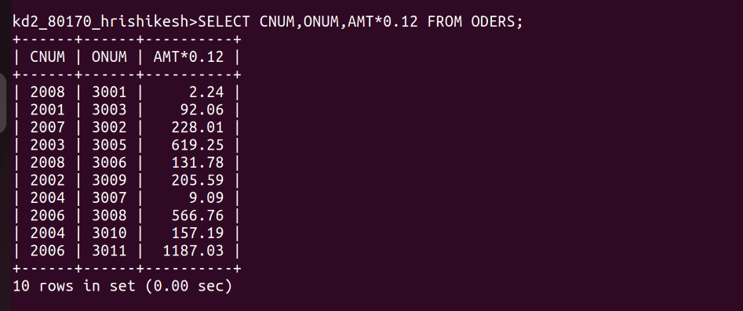
J
Q 2 ANSWER
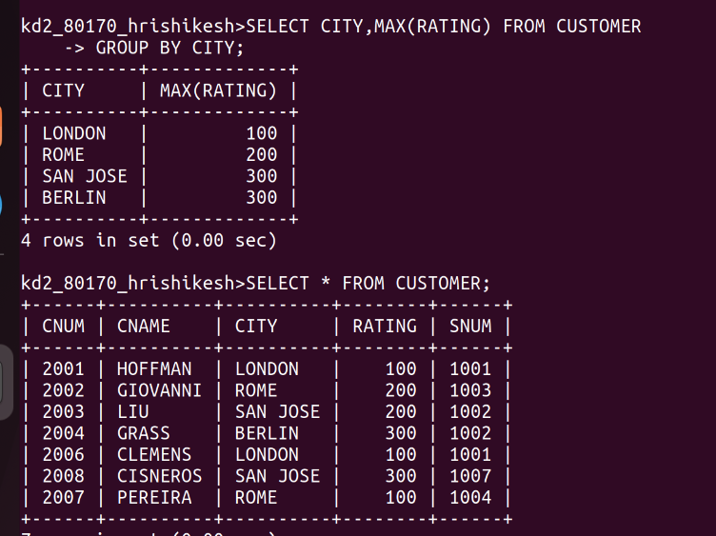
I

Q 3 ANSWER

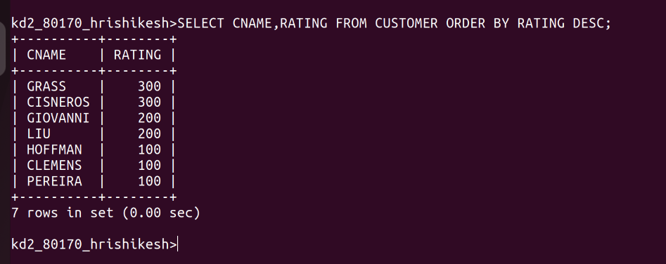

Q4 ANSWER
